Internal Function - Unit Testing

**name get_nft_name_from_number(uint64_t nft_number, name suffix);**

**-- version 10b (2023-09-30)**

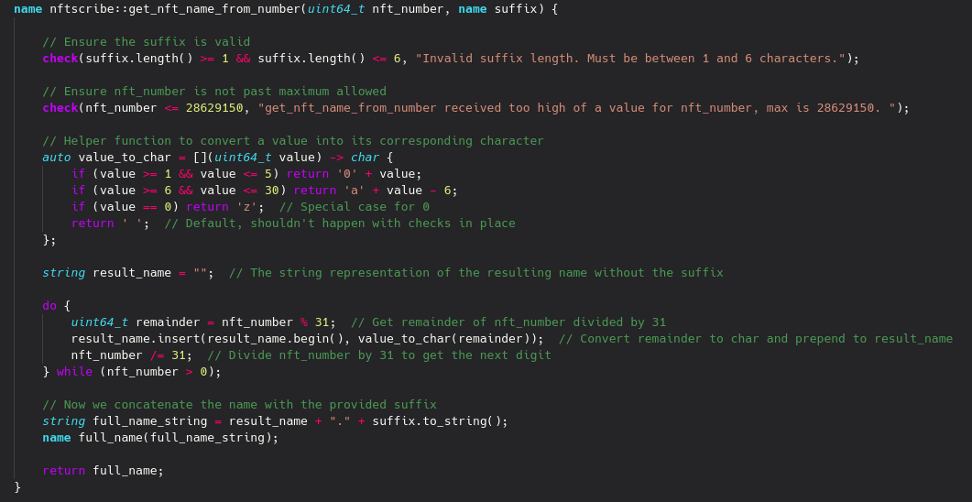

**PASSED** Name Resolution Test (961, name(“nft”))



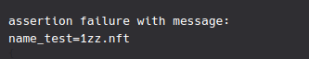

**PASSED** Max Name Test(28629150, name(“nft”))



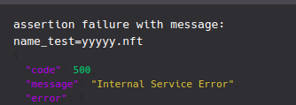

**PASSED** Min Name Test(0, name(“nft”))



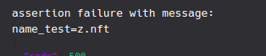

**FAILED & FIXED** 1 Past Max Test (28629151, name(“nft”))

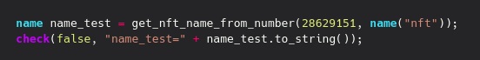

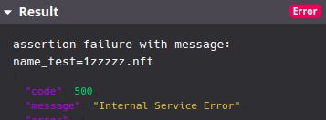

Redrafted function to 10b with additional max number allowed



**PASSED** 1 Past Max Test (28629151, name(“nft”))



